Vibe Coded Pong Game:

Introduction  
  
Pong is one of the first computer games that ever created, this simple "tennis like" game features two paddles and a ball, the goal is to defeat your opponent by being the first one to gain10 point, a player gets a point once the opponent misses a ball. The game can be played with two human players, or one player against a computer-controlled paddle.

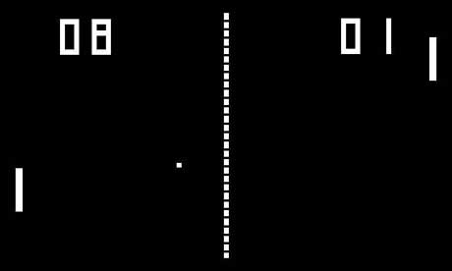

A) Functional Requirements:

1. The game should look like a replica of the image above.
2. The two paddles are represented by a simple thin white rectangle.
3. The ball is a simple square that abides to simple geometrical laws in its movements.
4. A halfway line should be represented by either while squares or while vertical dashes.
5. The ball should start from the middle going to either sides & once hit by a paddle, the ball can be rebounded to the other side.
6. The focus of the two players is to keep bouncing the ball, not letting it pass through the paddle through their side
7. If the ball happens to pass through a paddle a point is scored to the other side & is counted towards the game score.
8. The game score should be displayed on the top of the screen in a small-medium sized font.
9. The first to five points is the winner.
10. The game menu should contain only one button called play. Allowing the game to start.
11. The game has one player using one paddle & moving it through the up & down arrows on the keyboard.
12. The player should play against one computer agent.

B) Non-Functional Requirements

1. The entire game should be developed in plain C++, no additional libraries should be used to develop this game. The game should run just by pasting the code you provide & running it through the IDE.
2. The entire game should be developed in one cpp file “the main() file”.
3. The computer agent should be of medium proficiency, providing some competition but giving a window of opportunity to the player to win.
4. Movements of different elements should be smooth.